

PSU01A1 Specification

**GOS2022**

PSU01A1 Specification

**Power Switch Unit Version 01, Revision A1**

© Ahmed Gazar, 2024

|  |  |  |  |  |
| --- | --- | --- | --- | --- |
| Version history | | | | |
| Version | Date | Author | Change | Released |
| 1.0 | 2024-12-03 | Ahmed Gazar | Initial version of document. |  |
|  |  |  |  |  |
|  |  |  |  |  |
|  |  |  |  |  |

# **Content**

Content 5

Chapter 1 Introduction 6

1. Purpose 7

2. System Context 7

3. Board Interface 7

Chapter 2 Design Description 9

1. MCP23017 I/O Extender 10

ID.0001 10

2. Power Switch Circuit 11

ID.000 11

3. On-board Connectors 12

ID.000 12

4. PCB design 13

ID.000 13

ID.000 13

ID.000 14

Chapter 3 Testing 15

Chapter 4 Software Interface 17

Table Of Figures 18

# **Chapter 1** Introduction

## Purpose

The purpose of this document is to give a full description of the Power Switch Unit board.

## System Context

PSU01A1 is designed to be part of the modular main board development (MB02XX). This unit is responsible for providing an interface between the CPU board and the peripheries allowing the base software to individually switch on/off power supplies of each peripheral. The circuit is based on the MCP23017 I/O extender chip that is available via I2C interface. The board address is the same as the address of the extender chip. This address is configurable via the address I/Os.

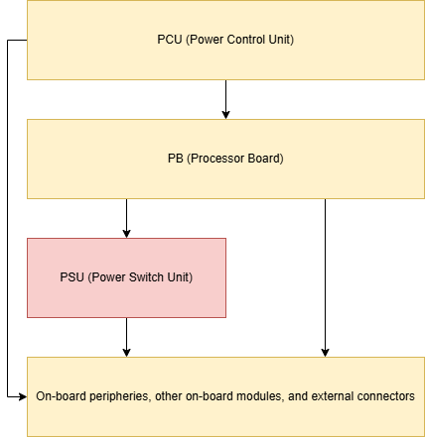

Figure : System Context

## Board Interface

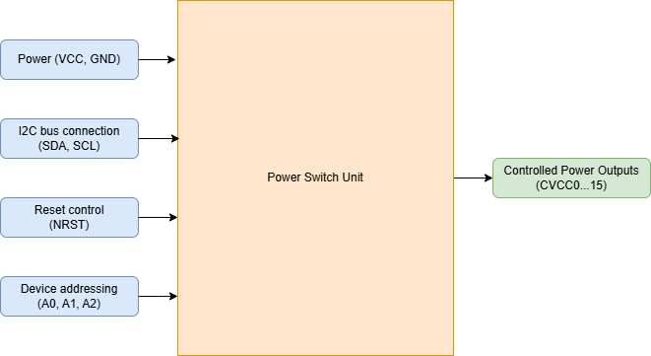

Figure : Board Interface

The board serves as a power interface between the CPU board and the peripheries.

The board has the following inputs:

* VCC and GND – these supply the extender chip as well as outputs
* SDA, SCL – I2C signals for communication with the extender chip
* NRST – reset control signal
* A0, A1, A2 – addressing input for I2C device address

The board provides the following outputs:

* CVCC0…15 – 16 individually controlled power outputs

# **Chapter 2** Design Description

## MCP23017 I/O Extender

|  |  |
| --- | --- |
| ID.0001 | Extender as I2C interface for switching power outputs |
| TODO | |

## Power Switch Circuit

|  |  |
| --- | --- |
| ID.0002 | Power switch circuit |
| TODO | |

## On-board Connectors

|  |  |
| --- | --- |
| ID.0003 | Connectors |
| TODO | |

## PCB design

|  |  |
| --- | --- |
| ID.0004 | Full PCB layout |
| TODO | |

|  |  |
| --- | --- |
| ID.0005 | Copper top layer |
| TODO | |

|  |  |
| --- | --- |
| ID.0006 | 2D PCB preview with standard color |
| TODO | |

## Parts list

|  |  |
| --- | --- |
| ID.0007 | Parts list |
| |  |  | | --- | --- | | **Part name** | **Description** | | IC1 | MCP23017 (SOIC28) | | J1, J2 | 1x4 pin header | | J3 | 1x16 pin header | | PWR_LED | 1206 SMD LED | | Q1, Q3, Q5, Q7, Q9, Q10, Q11, Q12, Q17, Q18, Q19, Q20, Q21, Q22, Q23, Q24 | 2N3904 (TO92) | | Q2, Q4, Q6, Q8, Q13, Q14, Q15, Q16, Q25, Q26, Q27, Q28, Q29, Q30, Q31, Q32 | 2N3906 (TO92) | | R1, R3, R4, R6, R7, R9, R10, R12, R13, R14, R15, R16, R21, R22, R23, R24, R25, R26, R27, R28, R29, R30, R31, R32, R41, R42, R43, R44, R45, R46, R47, R48 | 10 kOhm (1206) | | R2, R5, R8, R11, R17, R18, R19, R20, R33, R34, R35, R36, R37, R38, R39, R40 | 100 kOhm (1206) | | R49 | 1 kOhm (1206) |   TODO | |

# **Chapter 3** Testing

# **Chapter 4** Software Interface

# **Table Of Figures**

Figure 1: System Context 7

Figure 2: Board Interface 7